«Меридиан Петролеум» жауапкершілігі шектеулі серіктестігі
Товарищество с ограниченной ответственностью «Меридиан Петролеум» «Meridian Petroleum» Limited Liability Partnership
REVIEW
The educational program 7M07207 "Geology of Oil and Gas" presents the following key competencies that a master in petroleum geology should have: competencies of natural science, technical, computer training, as well as the skills of conducting training sessions, general social, cultural competencies.
The masters of this educational program have an idea about the methods of studying the chemical composition and physical properties of geological bodies, oil and gas source rocks, the capacitive-filtration properties of reservoirs in the subsoil, the methodological foundations for conducting prospecting and exploration work using the results of work on geological outcrops, when drilling wells, interpreting geophysical, geochemical and petrophysical research methods. They are able to analyze and put into practice various types of maps and profiles for forecasting and searching for minerals, assess predictive resources, calculate oil and gas resources and reserves, draw up calculation plans for oil and gas deposits; make an economic assessment of hydrocarbon deposits.
The program includes such modern disciplines as "Oil and Gas Systems", "Organic Geochemistry and Paleobiomarkers", "Regional and Local Modeling of the Evolution of Sedimentary Basins". The competencies obtained after studying each discipline and the corresponding module, data on the volume of the educational program are given in the Educational program 7M07207 "Geology of oil and gas".
The developed educational program of the master's program: "Geology of oil and gas" was developed in accordance with the Law on Education of the Republic of Kazakhstan, the National Qualification Framework, provided with educational materials and meets the basic requirements of professional standards. The structure of the presented curriculum is logical and consistent. The program under review can be used to train undergraduates of the qualification "Master of Technical Sciences" in the direction: "7M07207 - Oil and Gas Geology".

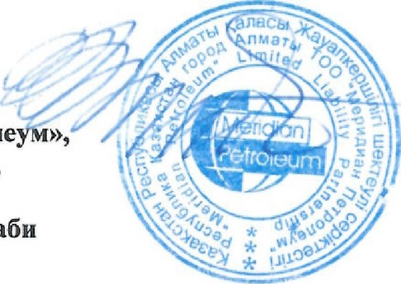
B.M.Kuandykov
President of Meridian Petroleum,
Doctor of Geological and Mineralogical Sciences,
Laureate of the State Prize in
Science and Technology. Al-Farabi

