REVIEW
for the educational program of the master's program: "Geology of oil and gas" developed in accordance with the Law on Education of the Republic of Kazakhstan, the State Educational Standard of the Master's of the Republic of Kazakhstan, study plan on the educational program of the master's program 7M07207 "Geology of oil and gas", the National Qualification Framework, professional standards and agreed with the Dublin descriptors and the European Qualifications Framework.
This educational program presents the following key competencies that a master in petroleum geology should possess: competencies of foreign languages, natural science and technical training, computer training, educational training, social training, cultural training, general competencies.
Masters of the educational program 7M07207 "Geology of oil and gas" have an idea about the processes and phenomena occurring in nature: on the material composition, structure and patterns of development of the earth's crust. They know the methods of studying and analyzing the composition and properties of geological bodies and minerals in the depths; - methodological foundations for prospecting and exploration work using the results of work on geological outcrops, drilling, geophysical, geochemical and laboratory research methods. They are able to analyze the chemical composition and physical properties of geological bodies, oil and gas source rocks, capacitive-filtration properties of reservoirs in the subsoil; -to apply in practice various types of maps and profiles for forecasting and searching for minerals.
The program includes such modern disciplines as "Oil and Gas Systems", "Organic Geochemistry and Paleobiomarkers", "Regional and Local Modeling of the Evolution of Sedimentary Basins", "Paleotemperature regimes of the subsoil, genesis and migration of hydrocarbons". Obtained competencies after studying each discipline and the corresponding module, data on the volume of the educational program are given in the Educational program 7M07207 "Geology of oil and gas".
The material is presented in the required volume and in an accessible form for use in the learning process. The text of the program is well-written, contains no fundamental remarks and is recommended for publication.

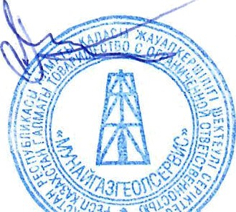
Director Bigaraev A.B. k.g-m.s.
of LLP "Munaigasgeolservice"

